Software Key Generation

Copyright 2002 – KarlNet, Inc.
License-it.com

License-it.com is a web application that allows registered Resellers and ISPs to generate software keys for use with KarlNet NDIS drivers and configuration (bin) files. Access the program by entering http://www.license-it.com. The following window will display:
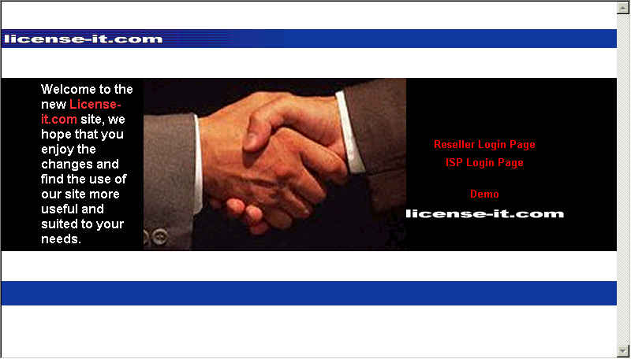

Figure 1

Select ISP Login Page from the application home page (see Figure 1) or click the ISP Login label from the summary page (see Figure 3). A window similar to the following is displayed:
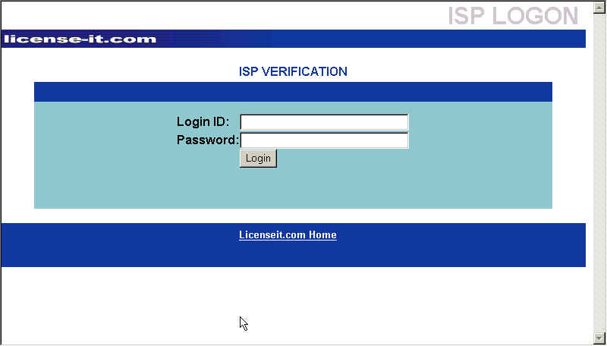

Figure 2

From is window, enter the ISP Login ID and password, then click the Login button. A window similar to the following is displayed:
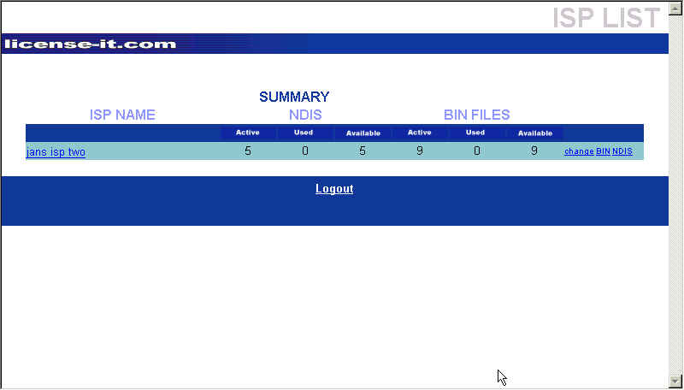
Figure 3
The window shows a summary for the ISP logged in to the application. Summary information includes the number of active, used, and assigned NDIS and BIN licenses. From this window you can display information about the ISP (see Figure 5 and associated text), change information about the ISP (see Figure 6 and associated text), or display information about the NDIS or BIN licenses assigned.

To display information about the NDIS licenses, click the word NDIS on the right hand side of the summary line. A window similar to the following is displayed:

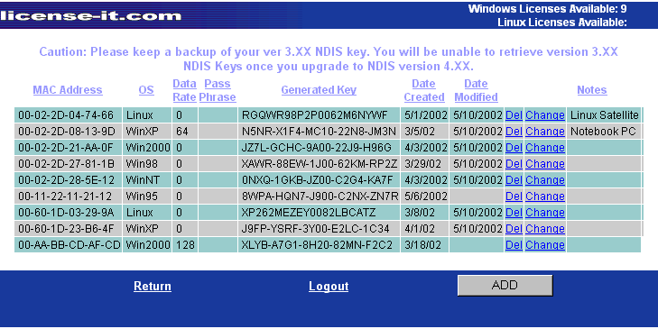
Figure 4

This window shows information about any keys that have already been generated for the NDIS licenses assigned to this ISP, the date the information was created and/or changed, as well as the number of licenses still available to this ISP. Using this window, you can change the key for the licenses already generated, or add additional keys, providing licenses are still available.
Note: Only NDIS licenses can be re-keyed online; to re-key BIN licenses, contact Reseller support.

To change information about a license that has already had a key generated, click on the word change on the appropriate line. A window similar to the following is displayed:
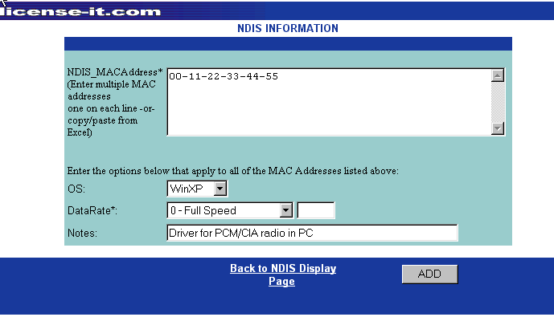
Figure 5

From this window you can change the operating system, the data rate, or add some informational notes. You cannot change the MAC address associated with the license. Once the desired changes have been made, click the CHANGE button. A new key will be generated and displayed in the NDIS Drivers List window (see Figure 10).

To generate a key for an unused (but available) license, click the ADD button from the window displayed in Figure 10.

This window allows you to enter the information necessary to generate the key to make the NDIS license usable.

To generate a key, enter the MAC address in the box in the upper portion of the window. You can specify a single MAC address, or multiple MAC addresses, but be aware that all addresses will use the same criteria (operating system, data rate, password) entered in the lower portion of the window. If you want unique information for each license, enter a single MAC address and repeat the steps for each subsequent address. If you enter multiple addresses, each address must be entered on a separate line.

Note: If you have the MAC addresses listed in another application (i.e., Excel, Word), you can copy and paste the information into this box. The single address per line requirement still applies.

After entering the MAC address, select the operating system and date rate being used, enter the desired password and any notes, then click the ADD button. A key will be generated for each valid MAC address entered in the box and a window similar to the following is displayed:
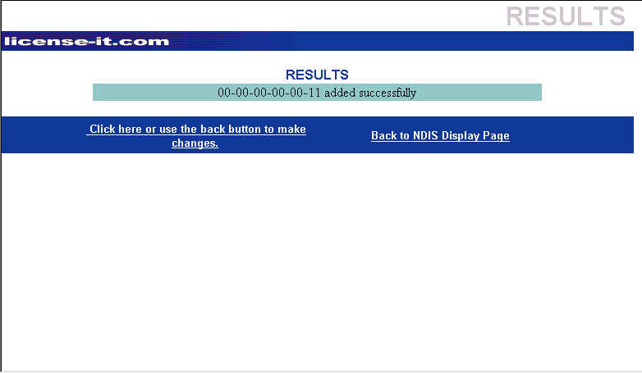
Figure 6

From this window you can make changes to the license just added or return to the NDIS Display page.

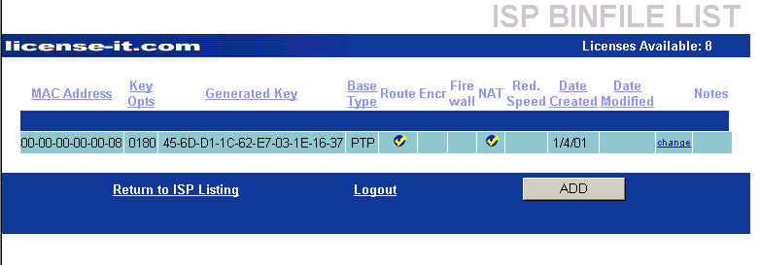
To add keys to BIN licenses, select the word BIN on the ISP summary window (Figure 9). If keys have already been generated for any licenses, a window similar to the following is displayed:

This window shows summary information about previously generated licenses (MAC address, key, features, etc.). Changes can only be made to the Notes section for any license displayed. Changes cannot be made for BIN files – you must contact KarlNet support.
Figure 7

Use this window to generate keys for available licenses. Click the ADD button. A window similar to the following is displayed:

To generate a key, enter the MAC address in the box on the upper portion of the window. As with the NDIS licenses, multiple addresses can be entered (either by keying or by copying from another application) but all addresses will use the same criteria specified in the lower portion of the window.

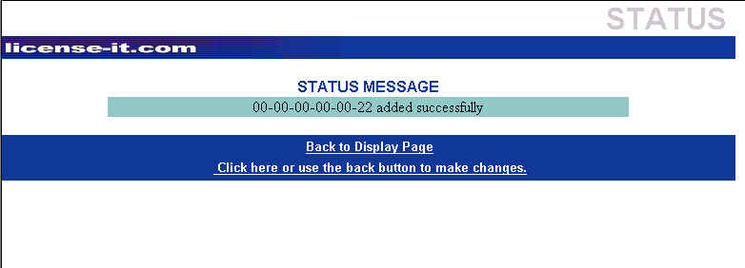
Select the Binfile name that will be used for this license, as well as the Binfile type and number of stations, if applicable. The features available with the Binfile selected will be enabled, allowing you to select desired features. Add any notes necessary, then click the ADD button. A window similar to the following is displayed:
If you need to make changes to any selection other than Notes, click on the bottom line to return to the previous window. Once you return to the Display page, only changes to the Notes can be made online. For all other changes with BIN files, you will need to contact KarlNet support.
Figure 8

